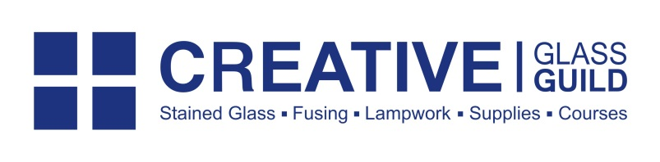
Entry Form
The
Awards

Name:
Telephone Number:
Email Address:
Address:

Category for Submission (please choose one):
Award for a Functional Fused Glass Object
Award for a Decorative Fused Glass Object
Award for a Flameworked Glass Object
Award for a Stained Glass Project
Award for a Copper Foiled Project

Name of piece:
Please tell us a bit about your inspiration, materials used and the process of creating this piece:

Please tick to confirm you have read and understood out Terms and Conditions (on next page)
Is this a piece that you have created since January 2014?

The Creative Glass Guild Awards Terms and Conditions
Submissions that do not meet these criteria will not be accepted.
- All submissions should be made by 25th May 2015. Any received after this date will not be considered.
- All submissions must be your own work.
- Six submissions from each category will be shortlisted by Creative Glass Guild and winners chosen by a panel at System 96. The judges’ decisions are final.
- The winners will be announced at Creative Glass Guild’s Summer Fair, which will be held on 5th July 2015.
- Each entrant may submit one piece per category.
- To enter, you must send a good quality photograph (JPEG) of your submission and a completed Entry Form to catherine@creativeglassguild.co.uk. If you are entering more than one category, please send a separate email and form for each submission.
- The Entry Form can be downloaded from our website. Follow the banner link on the homepage.
- You will receive an email to confirm your submission has been entered and it will be uploaded to a gallery on our website. You should receive this confirmation within four working days.
- All submissions must be made online; other forms of entry are not permitted.
- Submissions should be made with Spectrum, System 96 and Uroboros glass products.
- Mixed media pieces will be accepted as long as they consist of at least 50% glass.
- All submissions will have been made since January 2014.
- When the winners have been announced, prizes can be collected from our shop in Bristol or posted out to a UK Mainland address. Postage outside of the UK may incur a charge.
- Employees of Creative Glass Guild and Bristol Handmade Glass and those who have been previously employed by these companies are not permitted to enter the competition.
- All images submitted may be shared on our social media pages in conjunction with this competition.
As well as all terms mentioned above, submissions will also need to meet these category-specific requirements:
Award for a Functional Fused Glass Object
- Must be predominantly made of fused glass
- Must have a function other than being decorative
Award for a Decorative Fused Glass Object
- Must be predominantly made of fused glass
- Must be intended primarily as a decorative piece
Award for a Flameworked Glass Object
- Must be predominantly made of flameworked glass
Award for a Stained Glass Project
- Must be a leaded panel or piece, and can incorporate painting, engraving or other surface decoration.
Award for a Copper Foiled Project
- Must be a copper foiled panel or piece, and can incorporate painting, engraving or other surface decoration.

Full prize details will be announced shortly.
- The winner of each category will receive a prize worth more than £400, consisting of a selection of glass and materials relevant to that category. The Best in Show will be chosen from the winners of the other categories and will receive a £300 Creative Glass Guild voucher and £300 worth of glass and materials on top of the category prize.

